**South China Sea Petro-Politics**

**Tian Qiu**

**Introduction**

In the past century, crude oil prices have sharply increased, which coincided with the emergence of a global market for oil. “The oil crisis arose when the price of imported oil nearly quadrupled over the course of a quarter, forcing substantial adjustments in oil-consuming countries.” (Baumeister, 2016). As one of the biggest areas for oil exploration, the South China Sea has a staggering oil and gas reserve that will hugely affect the world oil market in the future. To control the world's oil resources and enhance the impact of energy pricing power, many countries have involved in the dispute over the ownership of the South China Sea. This paper will mainly focus on the oil demand, exploration, production and also insignificantly cover some potential territorial disputes in the South China Sea area.

**Oil Demand**

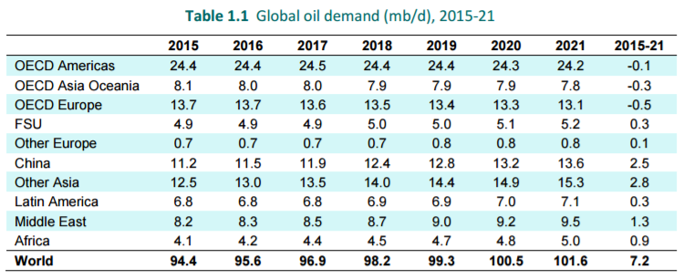Offshore exploration and production activities in the South China Sea are currently growing, given the huge potential of the deep-water oil reserves. The economic growth in Asian also leads to higher demands of oil, giving additional motivation for the exploration activities. The US Energy Information Administration (EIA) predicts local demand for liquid fuels to grow 2.6% annually and that local demand for gas will grow 3.9% annually over the next decade (Buszynski,2012). China is a big country that is highly dependent on imported energy. “China, in particular, aims to significantly increase its consumption of natural gas by 2020 and the South China Sea, with its potential for new gas discoveries, is a focus area.” (Laursen, 2013). “China’s dependence on foreign oil rose to 56.3% last year, and its dependence on natural gas imports rose to 21.5%. China will continue to be a major importer, with or without the South China Sea”, says Aston (Laursen, 2013).

Table 1. Global oil demand estimate (International Energy Agency, 2015)

The table above shows a forecast of the global oil demand from International Energy Agency. Asia’s key role in the future demand picture is reflected in the rise in the region’s share of global oil trade. “By 2021, non-OECD Asia will be importing 16.8 mb/d of crude oil and products, a rise of 2.8 mb/d compared to 2015. China remains central to this growth.” (International Energy Agency, 2015).

**Offshore Drilling**

Due to the influence of ocean geographical environment, offshore drilling should not only consider the influence of wind, wave, tide, tsunami and storm surge, but also consider the depth of ocean, sea moving towing and so on. The problem of offshore drilling could not easily be solved, so the structure of offshore drilling engineering equipment is very complex. Offshore drilling equipment technically similar to the land, but in the system configuration, reliability, degree of automation and other aspects of rigging requirements than the land more stringent. These factors have contributed to the difficulties of deep-water exploration, but also reflect the high-tech characteristics of deep-water oil and gas exploration in the South China Sea.

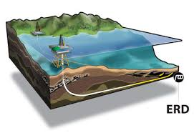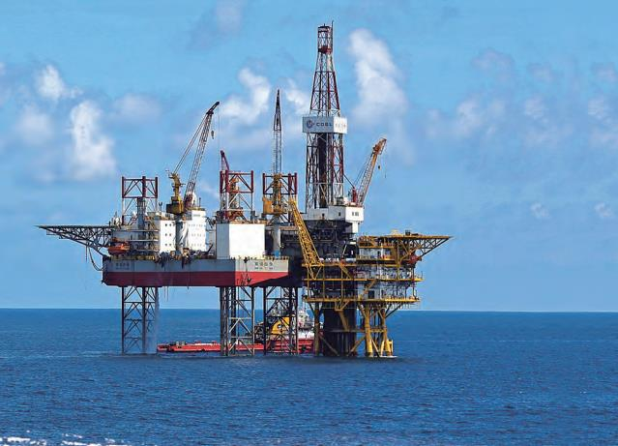

Figure 1. Offshore drilling platform Figure 2. Extended Reach Drilling

Oil and gas reservoir in beaches or lakes and offshore can be effectively exploited by using extended reach drilling (ERD) technology (Gao, 2009). In offshore drilling, extended-reach wells can be drilled from one platform to develop the surrounding satellite oil & gas reservoirs. Furthermore, “ERD technology can also be used to develop some marginal oil and gas reservoirs that cannot be exploited easily.” (Gao, 2009). ERD technology is efficient in exploiting offshore resources from onshore or land sites. It helps reduce the cost of offshore drilling.

Over the last decade, the drilling of extended reach wells has become a common practice in the oil and gas industry to improve field economics. However, it comes with several major limitations. First, the performance of gas-drilling horizontals is highly inconsistent in many areas. The reason is believed to be inadequate optimization of drilling parameters due to limited knowledge of factors affecting rock failure in wells (Song, 2014). Also, a literature survey indicates that the major technical and operational challenges in ERD include high torque and drag, limit of hydraulics, pipe racking constraints, mud handling capacity, offshore logistics, and platform space limitations (Song, 2014).

**Oil Reserves Estimate**

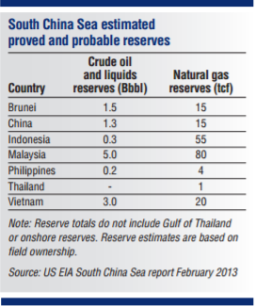At present, the South China Sea continental shelf have more than ten major oil basins, composing of an area of about 852,400 square kilometers, accounting for almost half of the total area of the South China Sea continental shelf. China's Ministry of Land and Resources data show that the South China Sea has more than 200 oil and gas structures, oil and gas fields of 180. According to the US Department of Energy's Energy Information Administration estimates, the South China Sea area of proven oil reserves of about 70 million barrels (1 ton of crude oil = 7.33 barrels of crude oil), daily output has reached 250 million barrels. The United States Geological Survey (USGS) and other institutions, studies have shown that the region's natural gas reserves, are likely to be equivalent to more than twice the reserves of oil.

Table 2. South China Sea estimated reserves (Laursen, 2013)

According to the analysis of the Guangzhou Marine Geological Survey of the Ministry of Land and Resources for many years, the Mesozoic strata in the northern part of the South China Sea are distributed in the depression of uplift in the east of the Pearl River Mouth Basin. The Mesozoic strata in the southern South China Sea are mainly found in the Nanwei Basin, the North Palawan and the West Palawan Basin. In these areas, it is likely that the distribution of oil and gas resources is quite extensive.

It is difficult to estimate the accurate amount of reserves in the South China Sea due to technical problems and territory issues. Also, there is little data about the contested Paracel Islands. However, a USGS 2010 analysis resulted in an estimate of 0.8 to 5.4 Bbbl of oil and between 7.6 and 55.1 tcf of gas in undiscovered resources (See table above). The USGS notes the complexity of the tectonic history of Southeast Asia. This history has included rifting and attenuation of continental crust, opening and closing of ocean basins, development of regional fault systems, and local uplifts (Laursen, 2013).

**Challenges for China Oil Industry**

At the same time, China's oil industry is also facing many challenges. The first one is the oil supply security challenge. The overall domestic oil is based on the low-grade resources exploration and development; production is difficult to grow substantially with existed conditions. Crude oil imports mainly concentrated on the Middle East and other geopolitical unstable areas. Besides, maritime transport is highly dependent on the Strait of Malacca and some other risks remain (Chen, 2012). The scale of oil reserves, the level of emergency response, and the quality of international oil cooperation cannot fully adapt to the international oil prices in recent years with increased volatility.

Second, the Chinese domestic oil exploration investment is inadequate. The oil industry is lack of competition and becomes more and more monopolized. Combined with geological difference and resource endowment differences, the company focused on exploration of high resource-abundant areas. On the other hand, risky exploration is usually not taken into consideration due to lack of investments. Some domestic enterprises have gained foreign blocks with permission and accumulated technical and managerial experience. However, there are still many restrictions on domestic access, which restricts diversified capital investment.

Third, there are constraints to sustainable development of the industry. Chinese old oil field has entered the later age of development and exploration. The operating costs are relatively high. Large-scale state-owned enterprise management mechanism is not flexible, imperfect governance structure, management level than the world-class enterprises are still a big gap (Chen, 2012). Oil overseas investment increased rapidly, but the ability to control and resist risks is not strong, profitability continued to decline. At the same time, the decline in employee income may bring old oil areas social stability risks.

Fourth, project construction and pipeline safety are under pressure. As China's urban and rural economic development and urbanization rate increases, the conflicts between oil production capacity and urban planning, land use have occurred. Pipeline construction and other infrastructure meet the growing intersection. Pipeline occupancy and third-party damage problems are becoming more serious. Pipeline safety operation risk, pipe inspection and integrity management have not yet been promoted; testing technology does not meet the security needs. Meanwhile, the government puts forward higher requirements for the environmental protection and operational safety of offshore oil development and pipeline transportation.

**Vietnam’s role in the South China Sea**

Vietnam has proven oil reserves of 600 million barrels, but there is still the potential for further growth. Most of Vietnam's oil exploration and production takes place in Cuu Long and Nam Con Son basins. Because there is no oil refinery in Vietnam, most of the country's oil is exported. The six oilfields currently being developed in Vietnam are: Bach Ho Oilfield, Rong Oilfield, Dai Hung Oilfield, Bunga-Kekwa Oilfield, Rang Dong Oilfield and Rubby Oilfield (Nguyen, 2016). Bach Ho Oilfield, Rang Dong Oilfield, Rong Oilfield and Dai Hung Oilfield are large oilfields, while the Bunga-Kekwa and Rubby fields are smaller oil fields.

     The government controls the upstream (including exploration and production) and downstream (transportation and refining) of the oil industry, as well as the natural gas industry. For the upstream oil industry, Petro Vietnam is the only company in Vietnam that can manage and engage in oil exploration and production operations. Any foreign investor wishing to undertake oil exploration and production activities in Vietnam must cooperate with Petro Vietnam. For the downstream business of the Vietnamese oil industry, a number of state-owned companies are allowed to import petroleum products, including Petrolimex and Petec company. Petrolimex is Vietnam's largest importer of petroleum products.

**India’s role in the South China Sea**

# The South China Sea is of significantly economic importance to India. Although India does not claim any territory in the South China Sea, the area means a lot in the consequence of safety and maritime trade issues. India puts heavily economic interests in the region.

# Trade and energy are two core domains on the economic interests. New Delhi is quite vocal about the recent developments in the South China Sea and the political leadership has consistently stated the peace and stability are of crucial importance to India. More than 97% of India’s trade volume is seaborne. Nearly 50% of India’s trade travel eastwards to the Asian-Pacific countries via the South China Sea (Jenner, 2016).

**Territorial Dispute**

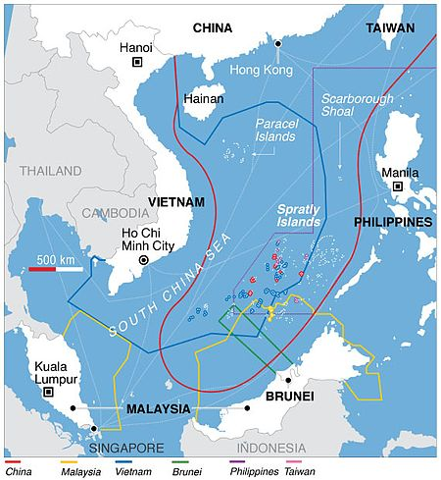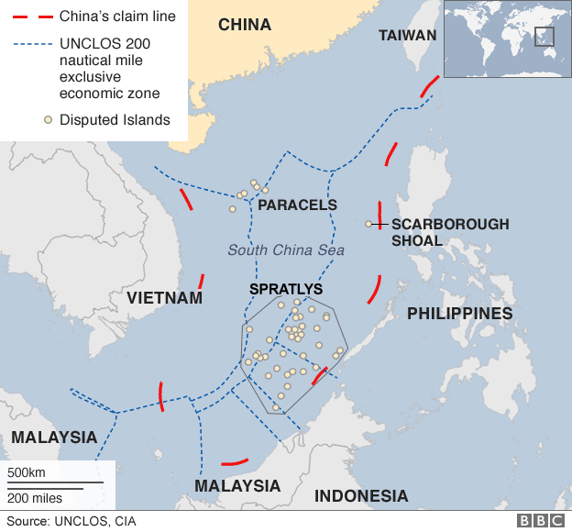

Figure 3. China’s claim line vs UNCLOS Figure 4. Territory claim lines (Voice of America, 2012)

The South China Sea territorial disputes involve both maritime boundaries and islands. “The spectre of overlapping territorial claims between Malaysia, the Philippines, Vietnam, Brunei and China is still rearing its ugly head, and shows no sign of going away soon. Recent incidents involving China, in particular, make for alarming reads.” (New Straits Time, 2016). Each country is defending its own fishery territory, as well as the giant amount of oil reserves. Besides oil, the South China Sea area is also one of the busiest shipping routes, which makes it so disputable and valuable.

On July 20, 2011, China, Malaysia, Vietnam, Brunei, and Philippines agreed to a set of guidelines. It is “a rare sign of cooperation in a row that has plagued relations in the region for years.” (Martina, 2011). As the China’s assistant foreign minister, Liu Zhenmin said, “This is an important milestone document for cooperation among China and ASEAN countries”. It helped solve the dispute exteriorly once, but the heat of dispute does rise again as fisherman attacks happen later on.

**Conclusion**

After we discussed about the oil demand, exploration, production and also insignificantly cover some potential territorial disputes in the South China Sea area, we can conclude that the disputation of oil in South China Sea will continue for at least several decades and by now, no one can give a solution that make every one satisfy.

Reference List:

# Baumeister, C. Kilian, L. (2016) Forty Years of Oil Price Fluctuations: Why the Price of Oil May Still Surprise Us. Journal of Economic Perspectives, Vol.30 (1), p.139-161.

The article lists some reasons for the increase in oil price.

# Laursen, W. (2013) South China Sea offers opportunities, challenges. Offshore, 2013, Vol.73 (9), p.44-49.

# Statistics about oil demand and reserves can be found.

# Gao, D., Tan, C., & Tang, H. (2009) Limit analysis of extended reach drilling in South China Sea. Petroleum Science, Volume 6, Issue 2, pp 166–171.

# It talks about some technologies about drilling.

# International Energy Agency (2015) Medium-Term Oil Market Report 2015.

# It gives several forecasts about the future energy trend.

# Song, J. (2014) Limit of Horizontal Wellbore in Extended Reach Drilling with Gas. ProQuest Dissertations and Theses.

# It provides limitations in ERD.

Chen, L. (2012) Research on main constraints in sustainable development of China oil-gas upstream industry. Energy Procedia, Vol.14, pp.325-330.

This article talks about some challenges and constraints of China oil industry.

# Nguyen, A. (2016) The South China Sea Award: Legal Implications for Vietnam. Contemporary Southeast Asia: A Journal of International & Strategic Affairs, Vol.38 (3), p.369-375.

# It talks about Vietnam’s role in the South China Sea.

Scott, D. (2013) India's role in the South China Sea: geopolitics and geoeconomics in play. India Review, Vol.12 (2), p.51-70.

It talks about India’s role in the South China Sea.

# Buszynski, L. (2012) The South China Sea: oil, maritime claims, and U.S.– China strategic rivalry. Washington Quarterly, Vol.35 (2), p.139-157.

# It gives some background about the US’s attitude toward the South China Sea.

# Jenner, C. (2016) The South China Sea: a crucible of regional cooperation or conflict-making sovereignty claims?

# It shows the global significance of the South China Sea.

Voice of America. (2012) Challenge Beijing in the South China Sea. Retrieved from

<http://blogs.voanews.com/state-department-news/2012/07/31/challenging-beijing-in-the-south-china-sea/>

It gives a boundary map.

Viet Nam News. (2016) Viet Nam protests Indonesian attack on fisherman. Retrieved from <http://vietnamnews.vn/politics-laws/346075/viet-nam-protests-indonesian-attack-on-fishermen.html#RfxdgqpeQa0fZulS.97>

It talks about the famous fisherman attack issue.

New Straits Time. (2016) Heat rises over maritime dispute. Retrieved from <http://www.nst.com.my/news/2016/03/135558/heat-rises-over-maritime-dispute>

It gives some opinions about the dispute.

Martina, M. (2011) RPT-China, ASEAN set “guidelines” on sea row, but no deal expected. Retrieved from

http://www.reuters.com/article/asean-southchinasea-idUSL3E7IK0M620110720

It talks about a set of guidelines in 2011.